***Pre-Work:***

*Introduction to data collection and analysis (Teacher)*

*Creation of Introduction presentation (Mentor)*

* **Meeting 1**
  + Teacher and Mentor- Walk the kids through the idea
  + Pick a topic as a class
    - Find a topic which they want to explore through data.
  + Outline that this means we need to get data
    - Discuss ways for gathering data. Include surveys as an option.
  + Survey Audience
    - Who do we want for a survey audience? For example; what grades?
  + Method of gathering
    - Anonymous vs in person
  + Brainstorm survey questions
    - Types of survey questions
      * Information about the person being surveyed
      * information about topic
      * Open text
      * Need 4 categorical, 4 numerical (put slides), 2 open text

***Pre-Work:***

*Creation of survey template (Mentor)*

* **Meeting 2**
  + Review survey template
  + Data consolidation discussion
    - Mentor to show the template that kids will fill out to turn in their survey data.
  + Discuss how to unbiasedly survey
  + Create data collection goals
  + Set survey volume goals
    - Need about 150-200 total
  + Timeline
  + Q&A

***Pre-Work:***

*Create Submission Area (Teacher)*

*Submission of Data (Kids)*

*Consolidate data (Mentor)*

*Create some graphs to get people thinking (Mentor)*

* **Meeting #3**
  + What did the students learn? How did they feel?
  + Review the data set
  + Review high level graphs
  + Review what we want to collect and how many images we need. Images can be the following types:
    - Graphs (hand drawn)
    - Graphs created with computer, using any software. Including: Google Sheets, Excel, RAWGraphs.io, Infogram, Tagxedo, Wordle, R
    - Drawings about the subject
    - Pics from the internet about the topic
    - Pics taken during the actual data collection
    - Quotes around what was learned
    - Quotes about what people said in open text
  + Brainstorm about other things we could gather
  + Pick a color scheme together as a class

***Pre-Work:***

*Create Lab (Mentor)*

* **Meeting #4**
* Demo + Lab (3 graphs on their data set)
* Set expectation on volume with kids

***Pre-work****:*

*None ☺*

* **Meeting #5 – *Optional* Mentor Meeting Check-ins with Teams** 
  + Show and tell
  + Q&A help
  + Graphing

***Pre-Work:***

*Submission of all images (Kids)*

*Review of content (Teacher and Mentor)*

* **Meeting #6 Class Review**
  + Decide on the large picture (pick 2-3)
  + Pick some awesome highlight pictures
  + Come up with the story of what we learned as a class
  + Get quotes from students on overall learnings
  + Do small write up

***Post-work:***

*Class write up (Teacher)*

*Mosaic Creation (Mentor)*

**Mosaic Mockup and details**

* Site: <https://mosaically.com>
* The mockup below has 20 pics so it’s poor quality
* Should try to get as many images similar to color scheme as possible
* Need 250-500 pictures

Example main graph

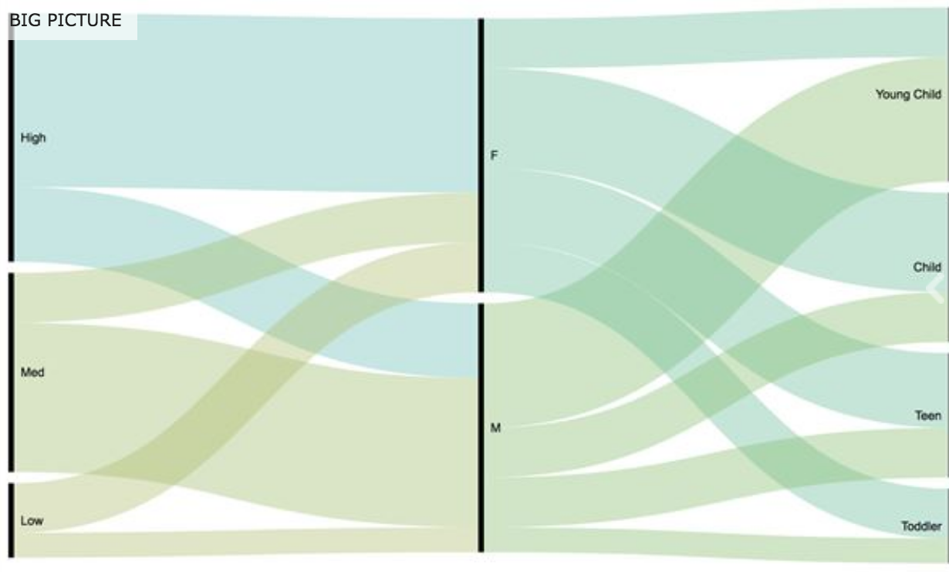

Example mosaic mockup

